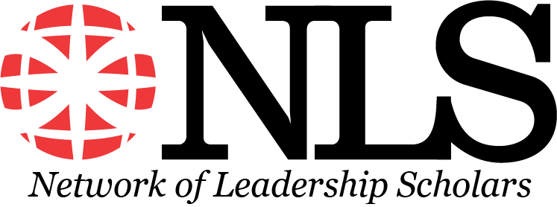

1st Annual Leadership Doctoral Consortium at AOM

Are you a doctoral student interested in studying leadership? If so, please join us for the 1st annual Leadership Doctoral Consortium at AOM, sponsored by the Network of Leadership Scholars, a micro-community within the OB division. This PDW is open to doctoral students at any stage interested in leadership.

We are planning an exciting, in-person AOM session on Friday, August 4th, 2023 (1:00pm-6:00pm) that will allow you to meet other doctoral students interested in leadership, prominent leadership scholars and engage in interactive sessions related to studying leadership. Happy hour with leadership scholars is the last hour of the session.

Goals & Content
This doctoral consortium provides a connection for leadership doctoral students to the leadership micro-community and the OB division. Attendees will have the opportunity to connect with and learn from junior and senior leadership scholars as well as other doctoral students interested in studying leadership.

Through discussions with prominent leadership scholars and interactive sessions, students will gain insights such as:
(1) advice based on their career as a leadership scholar
(2) how to brand yourself as a leadership scholar
(3) conducting multilevel analyses
(4) the role of the Network of Leadership Scholars

How to Register
- There is no charge to attend!!! (Though you must pay the AOM registration fee.)
- Pre-registration is required.
- To pre-register, please fill out the registration form by Friday, June 23rd, 2023.
- Participation will be limited to 50 attendees - so early registration is highly encouraged.
- Please email Amy Bartels (amy.bartels@unl.edu) with any questions.

We hope to connect with many of you!

NLS Leadership Doctoral Consortium Co-Chairs: Amy Bartels, Pol Solanelles, & Nathan Hiller
Link to register: https://unlcba.az1.qualtrics.com/jfe/form/SV_eWJHIAzKkX6d3HU

